Common Golf Injuries
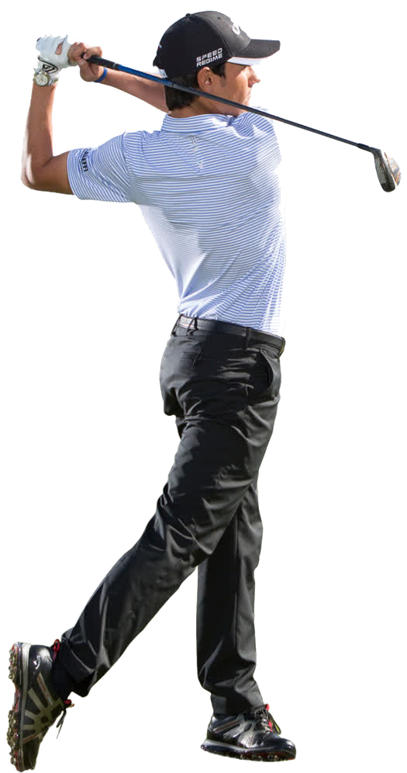
This Photo by Unknown Author is licensed under CC BY-NC
Golf is a sport that requires a lot of skill, flexibility, and focus. Due to the tremendous rotational stress placed on the spine and the tremendous load placed on ligaments and tendons, injuries are quite common. These injuries may be common in professional as well as recreational golfers. Many injuries can become chronic and nagging. To prevent these injuries, attention should be given to avoiding overuse, proper warm up with stretching and flexibility exercises, observing proper swing mechanics, and proper grip and set up mechanics. In addition, we should always observe proper nutrition and hydration.

Back pain
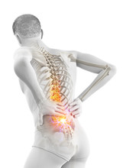
It is estimated that 85% of all individuals will experience back pain in their lifetime. Perhaps all golfers will experience back pain at some time. The rotational load on the spine, and the explosive unwinding predisposes to back injury. Certainly, over swinging and poor posture can place considerable stress on the ligaments, tendons, cervical, thoracic, and lumbar spine. Cervical, thoracic, and lumbar stretching programs prior to competition are imperative to maintain good back health. Adequate hydration provides nutritional support to the disc of the spine. As we age, we progressively lose our flexibility and muscle strength. Ligaments and tendons become stiffer and less flexible and spinal disc degenerate. Try to include a good stretching program one hour before your competition. You may also consult a local sports physical therapist. Avoid walking to the first to tee without adequate warm up. Symptoms such as tingling in your buttocks, and down the leg may be indicative of a more serious problem. If these problems persist you should contact your physician for evaluation.

Golfers elbow
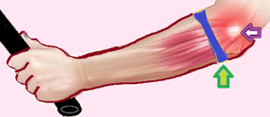
This Photo by Unknown Author is licensed under CC BY-SA-NC
This condition involves pain around the medial or lateral aspects of the elbow. Many times, this injury will cause a weak grip or inability to shake hands. Even minor tasks which involve gripping and grabbing may become difficult. Since most of the power for our grip comes from forearm muscles attached to the tendons of the hands, it is not surprising that gripping the golf club too tightly can cause this problem. Your daily occupation can also predispose to this injury, if there is extensive gripping, grabbing, carrying, and typing. This is a problem that can take several weeks to months to resolve depending on the duration. If soreness is experienced after a round of golf in this area you should begin rehabilitation immediately. You may start a program yourself of stretching and icing to these areas, along with analgesic creams and/or hemp creams topically. Adequate rest is always helpful. Other common treatments are tennis elbow splints, local injections, dry needling, and platelet rich plasma injections (PRP). If this problem becomes chronic you should consult your physician and/or physical therapist.

Knee pain
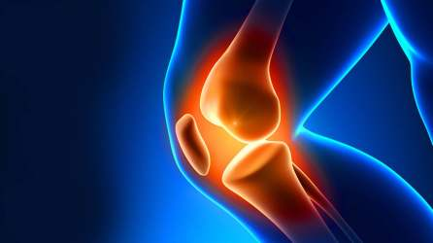
This Photo by Unknown Author is licensed under CC BY-ND
During the golf swing golf, the knee serves as a stabilizer for powerful lower body and hip rotation. Weakness of muscles of the anterior knee, the patellofemoral joint, may predispose to knee injuries. Strong anterior thigh muscles stabilize the patellofemoral joint during the golf swing. Indeed, strong muscles around the knee joint provides support for the meniscus doing rotation. If the muscles are weak, considerable stress is placed on the meniscus and predisposes to tears. The likelihood of tears of the meniscus and inflammation around the kneecap are much more likely if there is not adequate muscular support. You may experience medial or lateral knee pain, anterior knee pain and/or swelling after play. A good stretching program of the quadricep and hamstring muscles combined with strengthening exercises are extremely useful. Individuals with chronic degenerative arthritis, and chronic knee pain tend to have muscles that are weak. It is imperative that we always continue flexibility and strengthening exercises of the knee. For chronic swelling, ice therapy may be helpful. Over-the-counter topical analgesics, and hemp cream may be useful. Always consider a period of rest for acute injuries while performing rehabilitation. If you continue to experience medial knee pain and significant patellofemoral pain, you should consider visiting your physician or a physical therapist.

Rotator cuff injuries
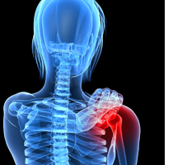
This Photo by Unknown Author is licensed under CC BY-ND
This is one of the most common injuries in sports as well as activities of daily living. The shoulder is supported by strong muscles. Much of this support is provided by the rotator cuff muscles. When adequately conditioned, these muscles allow the shoulder to rotate within the joint with ease. If the muscles become weak, then the rotator cuff tendons and bursa of the shoulder become inflamed and you may experience anterior, lateral, and posterior shoulder pain. If the pain persists and is not addressed, then the muscular support weakens further. Since the lateral and posterior neck muscles, and arm muscles support the shoulder, these areas may also become inflamed and produce pain. Unfortunately, the weaker the rotator cuff, the more likely you are to have more problems. If inflammation persists, you may experience progressive pain, and occasionally, the shoulder may become immobile, possibly producing a frozen shoulder. In golf, the rotator cuff can be injured from a poorly executed golf swing, and overuse. You may develop a rotator cuff tendinitis, a subdeltoid bursitis, and if the problem remains chronic, the rotator cuff may degenerate and tear. If the shoulder range of motion becomes limited, range of motion exercises are encouraged. Exercises such as straight abduction, supraspinatus exercises, and shoulder shrugs are encouraged. Only light weights are needed for rehabilitation. Indeed 1-5 pounds are more than adequate for shoulder rehabilitation. For chronic problems anti-inflammatory drugs, analgesic creams, and hemp creams are useful. Remember, the weaker the muscles are around the shoulder the more problems you may have with the shoulder. You must always maintain good rotator cuff strength!

Neck injuries
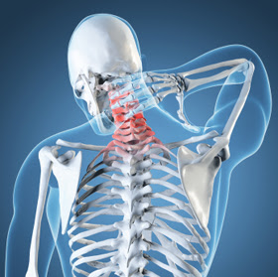
This Photo by Unknown Author is licensed under CC BY
Neck injuries are common in golfers who do not properly rotate the lower body. The constant swinging using the upper body we will place repetitive load on the neck muscles which support the shoulders. Later, there may be spasms of the neck muscles with pain around the neck and shoulders. A good cervical stretching program is imperative in a new golfer. Frequent breaks with stretching are also helpful when practicing. Certainly, arthritis around the cervical spine may predispose to chronic pain and spasms. As with most acute injuries ice massage is recommended along with analgesic creams and perhaps hemp creams. Nonsteroidal anti-inflammatories are useful. If you continue to have chronic pain, you should consult your physician or a physical therapist.

Summary
Proper mechanics, good muscle strength, flexibility, and nutrition are all important in preventing injuries in golf.

Nonsteroidal anti-inflammatory medicines although effective, are for short term use, and may not be indicated in certain individuals. Injections, such as corticosteroids, PRP, dry needling, and stem cell treatments can be considered for certain refractory cases. Some of these treatments are more costly and may be more invasive. Generally, topical anti-inflammatory agents, analgesic creams and hemp creams are less problematic. Excellent home rehabilitation programs for these injuries that include stretching and strengthening exercises, are available online. You should always consider consulting your primary care physician before using medications and if you are experiencing ongoing medical problems.

The recommendations given here are not those of the Columbus Golf Authority and are based on the training and experience of the author.

William E. Roundtree MD, FAAFP
Family Practice and Sports Medicine
Columbus, Georgia 31906

